Logging is a means of tracking events that happen when some software runs. Logging is important for software developing, debugging, and running. If you don’t have any logging record and your program crashes, there are very few chances that you detect the cause of the problem.
The simplest way of logging is to write print statements in the program to check what has gone wrong where. But the main drawback here is at the time of sending the program to the client, you have to either comment or remove those print statements. Moreover print statements appear on console only whereas logging allows you to print the log messages on the console, file as well as database.

Python Logging Levels
There are five built-in levels of the log message.
- Debug: These are used to give Detailed information, typically of interest only when diagnosing problems.
- Info: These are used to confirm that things are working as expected
- Warning: These are used as an indication that something unexpected happened, or is indicative of some problem in the near future
- Error: This tells that due to a more serious problem, the software has not been able to perform some function
- Critical: This tells serious error, indicating that the program itself may be unable to continue running

Each built-in level has been assigned its numeric value.
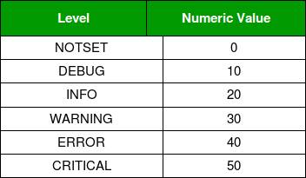

Key Components of Python Logging
- Loggers: Used to log messages. You can create custom loggers with different names and configurations.
- Handlers: Used to configure where log messages go (e.g., console, file).
- Formatters: Used to specify the format of log messages.

How exactly log messages they work?
You need to set the log level i.e. debug or info or warning or error or critical
Then you actually log the message/s.
The message or messages will go to the level which is set and all the above levels but not the lower level.
e.g. if you have set level as “warning”
and if you log the message, the message will go warning and all the above levels i.e. error and critical also. But the message won’t go to debug and info.

